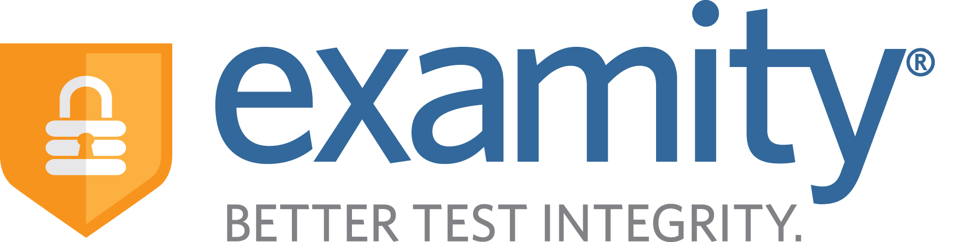

Instructor Quick Guide

For Stand-Alone Access

\

Instructor Quick-Guide

For Stand-Alone Access



**1. Accessing Examity**

Access your Examity dashboard at <https://prod.examity.com/lsu>, by logging in with credentials provided.

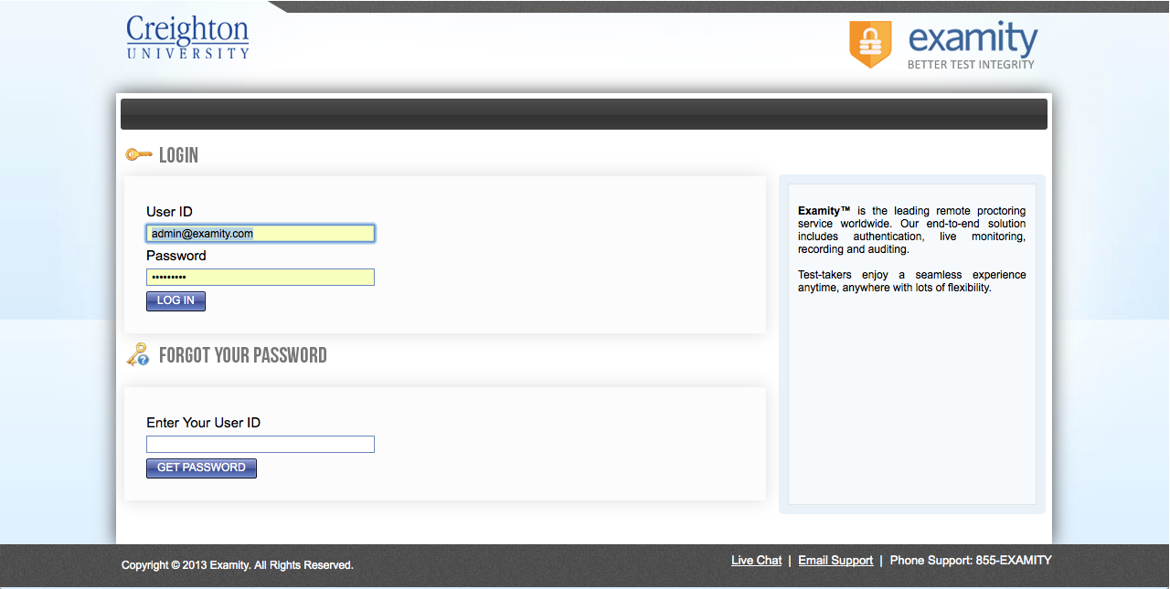

**2. Navigating the Examity Dashboard**

***First, double click on the date/time in the upper right hand corner of your screen to set your time zone and other account information.*** Once that is done, you may navigate the dashboard as needed. Access all four areas of your Examity dashboard by clicking the links on the top navigation bar, or the icons you see upon login. 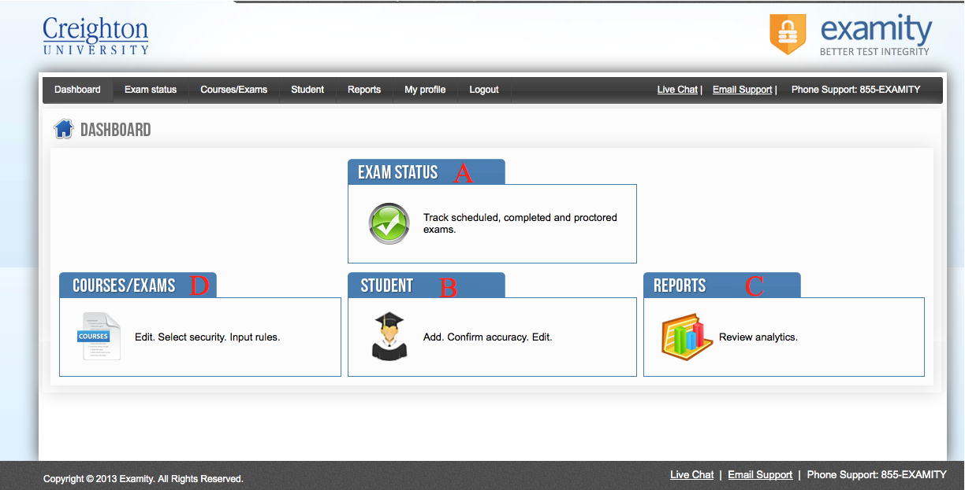

**A)** EXAM STATUS – view the status of student exams (scheduled, in progress, pending at auditor, approved by auditor, cancelled). This is where you may review exam videos, once they have been approved by the Examity auditing team.

**B)** STUDENT - view/edit student level details, special accommodations and enrollments.

**C)** REPORTS - review all exams associated with your courses. Filter by course or student name, and download Excel/PDF versions of these reports to help track your students.

**D)** COURSES/EXAMS – access a list of your courses and any exams within each.

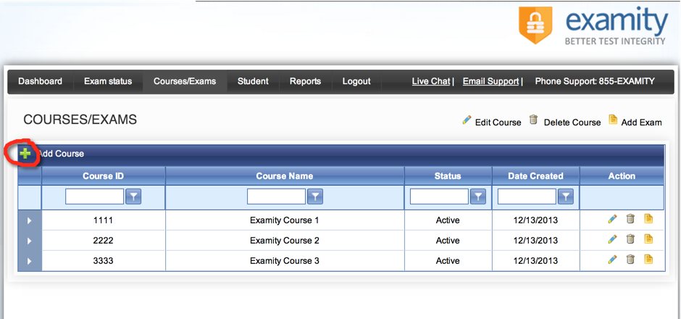**3. Create a Course** Click on the “Courses/Exams” icon on your dashboard, and then the green (+) symbol in the upper left corner of the screen.

Enter course ID and name. 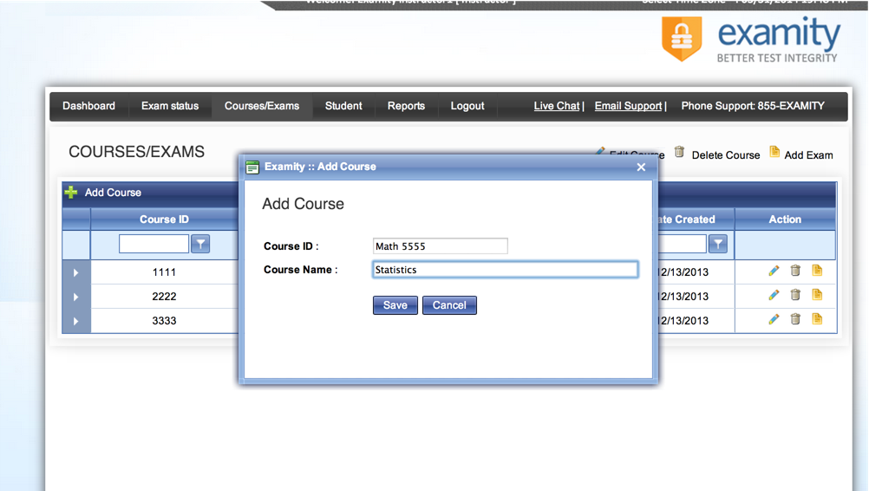

**4. Add/Enroll/Manage Student Data**  
To add students data, click on the “Students” icon of your dashboard, and then the green (+) symbol in the upper left corner of the screen. Edit student information as you add them, or by clicking the “Edit Student Details” pencil icon to the right of their name after they are added. You may enroll students in your classes by clicking the “Enroll Student” yellow paper icon to the right of their name and choosing your name and course.

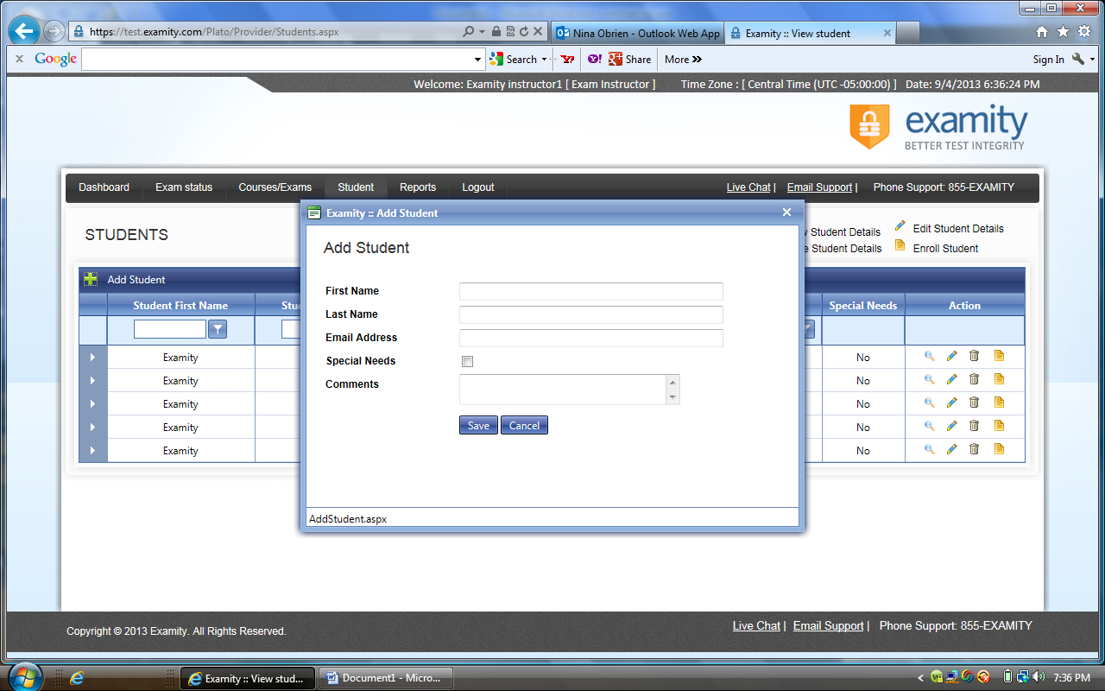

**5. Create an Exam**

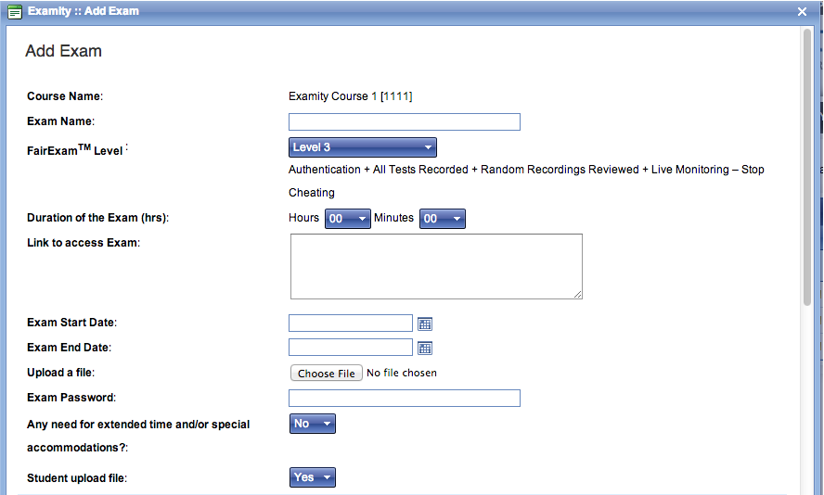Click on the “Courses/Exams” icon on your dashboard, and then the “Add Exam” yellow paper icon to the right of the appropriate course name. Complete all necessary exam details, including the link to your exam within the LMS, and the FairExam® security level of your choice.

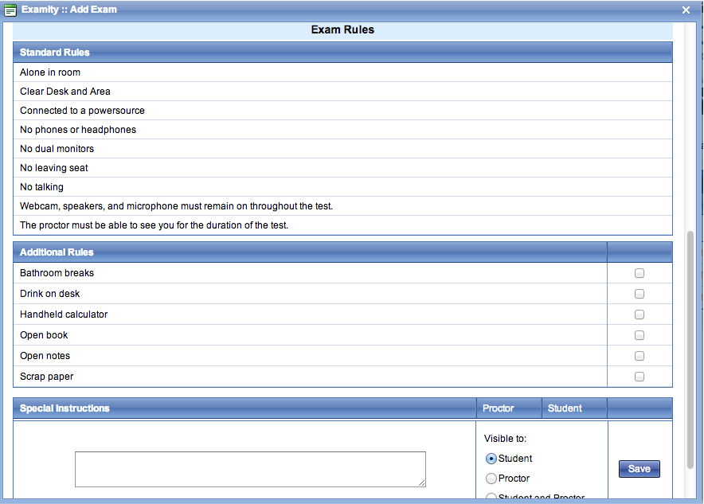Customized exam rules may also be chosen (i.e. allow open book or use of a handheld calculator) or additional instructions typed free-form within the box. Click “Save” for any special instructions and “Update” to confirm all exam details/rules.

If any students require test accommodations, such as extra time, please ensure that proctors are made aware in advance, by selecting “Yes” within exam details and entering accommodation information at the student level within Examity - click on “Students” icon in dashboard, and the pencil icon next to the name of the student needing accommodations. Select “Yes” in the “Special Needs” field, and enter the appropriate information within the “Comments” box.

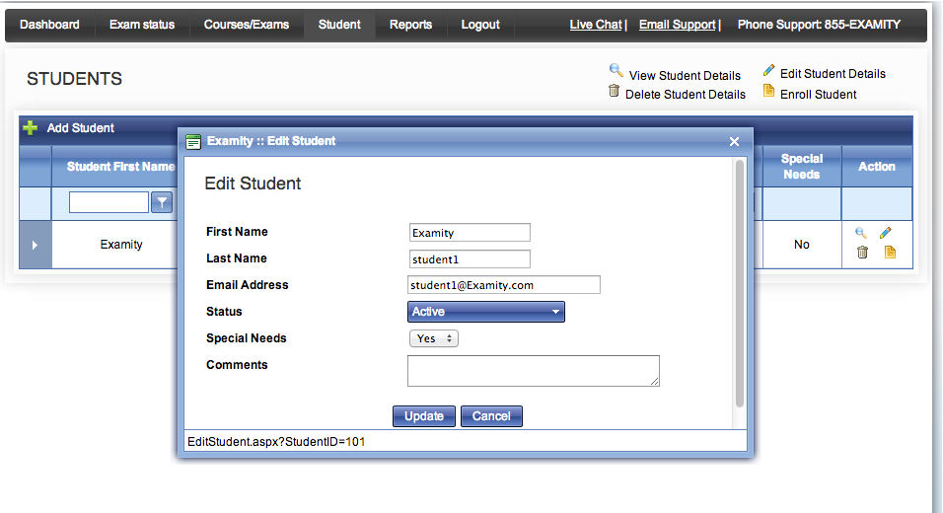

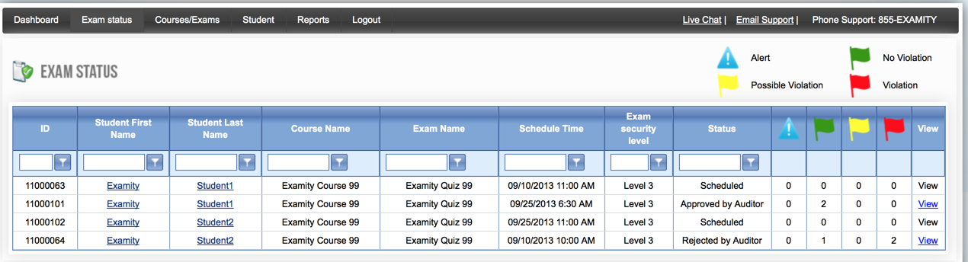**7. Tracking Exam Status**Click on the “Exam Status” icon on your dashboard to view the status of students’ exams (scheduled, in progress, pending at auditor, approved by auditor) and whether there were violations/alerts.

Once the exam video has been audited, you may view, especially if you are informed of a violation. View the footage by clicking the blue “View” link to the right of a student’s exam row. Examity stores student exam footage for 30 days, after which it is deleted to ensure privacy for all parties involved. 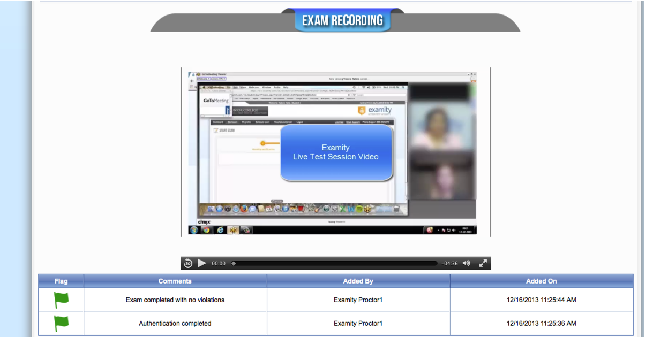

**8. Instructor Support**

(o): 855-392-6489

(c): 508-942-8429